**Starshot Optical Design Considerations**

**James R. Leger**

**31 January 2020**

**Executive summary**

An optical design is outlined that is capable of meeting the laser propulsion requirements of Breakthrough Starshot. In particular, the design offers solutions to the required laser power, optical radiance, beam steering, beam focusing, and atmospheric turbulence compensation specifications. The design concentrates on the beam forming optics, and is motivated by reducing the cost of all components. The requisite optical metrology and control systems are specified, but a detailed design of these systems is outside the scope of this report.

The laser propulsion optics consist of an array of individual optical modules, hexagonally close-packed in a circular array with a diameter of 2700 meters. Each module consists of a fiber amplifier that is fed by a common master oscillator, establishing coherence across all modules. The fiber feeds to the modules are approximately path-length balanced to reduce the coherence requirements of the master oscillator.

An individual module consists of a 30 cm collimation optic fed by a Ytterbium-doped fiber amplifier. The module mounting is fixed and is designed to achieve optimal pointing when the target star is at zenith. The array has the ability to steer and focus the beam for the required illumination period without expensive mechanical motion. In addition, the effects of atmospheric turbulence are minimized by adjustments made to each module.

The module design introduces several novel concepts to achieve beam steering and focusing at low cost. The steering is accomplished by transverse micromotion of the fiber amplifier tip that illuminates the collimation optic, coupled with a phase shift applied to each module by an electrooptic modulator. The focus is performed by a combination of transverse and longitudinal fiber motions. Thus, with a simple 3D micromanipulator and phase shifter, the beam shape can be conditioned without requiring any large and expensive motion control. The same hardware can compensate for the atmospheric aberrations of piston, tilt, and quadratic curvature.

Equations are developed to estimate the array requirements and performance. We calculate the overall Strehl ratio reduction resulting from incomplete array fill factors, errors in the array phasing, and atmospheric turbulence to be 0.46. The calculated fiber amplifier power per channel is 3 kilowatts and the required line width of the master oscillator is 6 MHz.

**Starshot Optical Design Considerations**

**Introduction and scope**

This report describes a straw-man optical design solution for the laser system required by Breakthrough Starshot. The design assumes that reliable and inexpensive laser amplifiers are available with single spatial mode powers in the 3-5 KW regime. These have previously been demonstrated using Ytterbium-doped fiber amplifiers ( = 1.05 m). It is anticipated that further refinement will make these amplifiers the light source of choice. The report lays out a general design strategy and develops general equations that can be used to assess the requirements and performance of the optical system.

The following requirements are assumed in the design:

* A laser aperture diameter of 2700 meters, proposed by the flight dynamics team, is used in all calculations.
* The total power of the laser, proposed by the flight dynamics team, is 100 GWatts.
* The light source will have a wavelength of 1.05 m
* To achieve the required radiance, the beam is required to be a single spatial mode.
* The beam will be directed towards a specific target location in the sky. This location is determined by the position of the destination star at specific dates and times
* The target will be tracked for a short period of time to compensate for earth’s rotation to allow a CW beam to be applied to the target
* The system will permit beam focusing from 35.8 Megameters (geostationary orbit) to infinity, with closer distances possible
* The system will be designed to compensate for atmospheric aberrations
* The system design will permit expansion in size to enable higher radiance applications without excessive redesign
* The system will be fault tolerant
* The system design will be driven by cost considerations

It is anticipated that highly accurate metrology data will also be required by this system to enable the various compensation systems described in this report. However, the metrology optics and the performance of the feedback systems are not considered in the current study. Rather we concentrate on the optical characteristics of the light generation system and describe its performance as a function of various design parameters.

**Array geometry and laser layout**

The power-on-target specifications of most Starshot scenarios require projecting single spatial laser mode power from earth over a large baseline. For instance, one scenario requires generation of a spherically phased beam over a 2700-meter aperture diameter. Conventionally, laser power is directed to a particular sky location by mounting the collimated source on a steerable gimbal so that the center of the beam is pointed in the desired direction. However, with the large aperture size required by Starshot, this is clearly impractical.

An alternative design uses the layout of a phased array antenna. The full aperture is divided into many sub-apertures, with each sub-aperture pointed in a fixed direction towards the target star location at zenith. This is illustrated in fig. 1, showing a side view of the array in one dimension indicating the inclination angle of each sub-aperture pointing to the target. We note that there are several variations to this geometry, including a central core of apertures that are steerable with conventional altazimuth mounts for lower power applications that require increased flexibility.

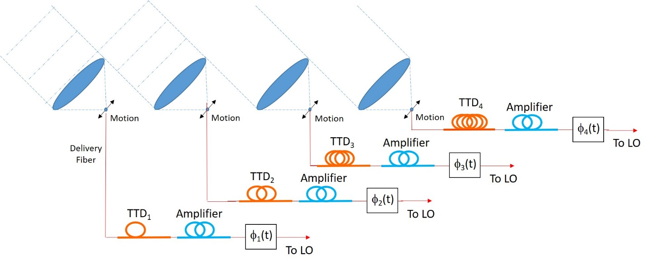

*Fig. 1. Optical layout of laser array. TTD = true time delay, corresponding to additional fiber for path length balancing. Electrooptic modulators are contained in the phase boxes. LO = master oscillator.*

From the perspective of the target, the aperture appears to be completely filled with sub-arrays, as seen in fig. 2. Of course, the projection onto the terrestrial plane gives rise to an elliptical array, but we consider a simple circular geometry in this report for convenience. The overall radiance of the laser beam generated by this array is reduced by three factors. First, an incomplete fill factor produces side lobes (called grating lobes in analogy with a diffraction grating) in the far-field. Second, phase errors across the individual apertures cause a broadening of the main lobe. Finally, (identical) phase errors across each sub-aperture produce additional side lobes. All three of these effects result in the reduction of power in the main lobe and a corresponding reduction in the useful amount of power on the target. The Strehl ratio can be defined as the ratio of the on-axis power resulting from an imperfect phased array compared to the equivalent array aperture filled with a perfectly uniform beam and a flat wavefront. Thus, the Strehl ratio expresses the reduction of radiance suffered by an imperfect array and can be used to estimate the reduction of performance from nonuniformities in amplitude and phase.

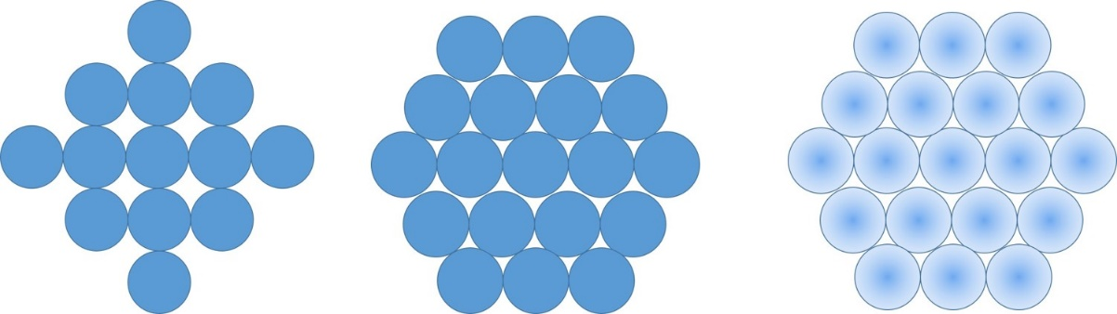

*Fig. 2. View of array from perspective of target. a) Rectangularly close-packed, b) Hexagonally close-packed, c) Gaussian illumination.*

It can be shown that the Strehl ratio of an array is given by:

$\frac{{\left|〈\hat{u}(r,θ)〉\right|}^{2}}{〈{\left|\hat{u}(r,θ)\right|}^{2}〉}$ (1)

where $\hat{u} (r,θ)$ is the complex field and $〈⋯〉$ indicates a spatial average. From this equation, it is clear that the nonuniform intensity distributions shown in fig. 2 result in a reduction in the Strehl ratio of the beam. For uniformly filled individual circular apertures, the Strehl ratio is simply given by the fill factor of closely packed circles (0.785 for rectangularly close packing in fig. 2(a) and 0.907 for hexagonally close packing) in fig. 2(b). If the aperture is filled by the approximate Gaussian-shaped beam from a fiber laser, there is an additional reduction of the Strehl ratio which results in a maximum Strehl value of 0.738, as seen in fig. 2(c). The calculation of this and related values is contained in the appendix.

Optical systems are available that can reshape Gaussian beams into more ideal distributions, including a uniform square shape that would result in a Strehl ratio of 1.0 . In this case, the optical aperture appears as completely covering the aperture when viewed in the direction of light propagation. However, at the current time these systems involve sophisticated optical components that would increase system cost and complexity. A cost-benefit analysis would be required to determine the most beneficial approach. For this analysis, we will assume that the beams have been reshaped and that the wavefronts coming from each aperture are uniform in amplitude and phase, with a square shape (from the perspective of the target). The results of this analysis can be applied to the non-beam-shaped case by multiplying the predicted radiance by the product of the two Strehl ratios described above.

Returning to fig. 1, we see that each sub-aperture is fed by its own power amplifier, where the amplifiers share a common master oscillator. By phasing the apertures properly, it can be seen that the wavefronts can be adjusted in delay to form a continuous plane wave across the array. In the ideal case, this resulting beam produces a diffraction-limited beam equivalent to an aperture that is the size of the extended array.

In the case where no beam shaping is performed, the optical components of each sub-aperture are quite simple. If the delivery fibers from each fiber amplifier are assumed to have sufficiently large numerical apertures (> 0.15) such that no expanding lenses are necessary, a single collimating lens is the only optical component required for each sub-array. If the delivery fibers have very low NA’s, it is possible to include an expanding lens on the end of the fiber by melting a spherical cap on the fiber tip. In each case, the optical components are minimal for this part of the system.

The collimating lens must be of high quality to preserve a wavefront with an adequate Strehl ratio. From eq. (1), it is possible to show that the resulting Strehl ratio *S* for a uniform intensity beam with a phase error of variance 2 is simply given by

$S=1- σ^{2}$ (2)

(for small phase aberrations). High Strehl ratios are straightforward to achieve with conventional refractive optics over modest sub-aperture sizes ( $\sim$ 30 cm) but can be relatively expensive to produce. A second possibility is to use a diffractive optic for the collimating lens. Diffractive optics can be quite efficient at the relatively low NA values envisioned here, and their dispersion requirements can be met in a straightforward manner using modestly narrow-band amplifiers. The advantage of diffractive optics for our layout is that they are flat and can be easily fabricated in a square or 100 % filled hexagonal format, resulting in a 100 % fill factor and no Strehl ratio degradation. Aberration correction and aspheric wave shaping can also easily be incorporated into their prescription. Current manufacturing methods are more expensive than conventional refractive elements, but future manufacturing approaches may make these elements competitive.

**Beam focusing**

In the non-focusing condition, the array produces a planar wavefront across its 2700-meter aperture. The boundary between near-field and far-field diffraction is approximately given by $d^{2}/λ$, where *d* is the diameter of the aperture and $λ$ is the wavelength of light. For the proposed aperture of 2700 meters, this

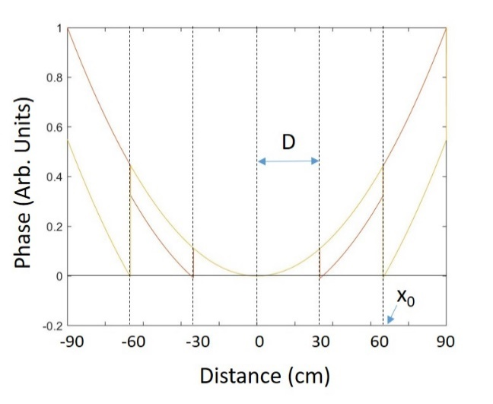

*Fig. 3. Parabolic phase required by virtual lens (continuous curve) and piece-wise continuous phase implemented on array.*

corresponds to a distance of $7.3 ×{10}^{9}$ Km or approximately 48 AU. For target distances that are substantially smaller than this, the beam requires positive curvature to enable the light to focus onto the target. This curvature can be applied by adjusting the phase of each sub-aperture to approximate the required spherical curvature across the array.

The required phase across the array is given by the desired focal distance. Our analysis assumes that the paraxial condition applies and that a spherical wave can be approximated by a parabolic function. This restricts the focal distance to be greater than approximately ten times the aperture diameter, or 27 Km. Since any target would have to be above the atmosphere, this condition is clearly met. Therefore, we can express the required field $\hat{a}\left(x,y\right)$ as

$\hat{a}\left(x,y\right)=exp\left\{i ϕ(x,y)\right\}$, (3)

where

$ϕ\left(x,y\right)= - π\frac{(x^{2}+ y^{2})}{λ z_{0}}$, (4)

the hat denotes a complex number, and $z_{0}$ is the distance from the laser array to the target. The negative sign is chosen to indicate a positive curvature required for a focused beam.

Fig. 3 shows the proposed phasing of the array to control target focusing. The cross section of the required phase corresponding to eq. (3) is shown as the continuous parabola in the figure, where this phase covers the entire array aperture. Each sub-aperture of the array of diameter *D* is shown greatly enlarged in the figure for clarity. If we consider one particular sub-aperture located a distance $x_{0}$ from the center of the aperture, we can calculate the required phase across this single sub-aperture by performing a Taylor expansion of the paraboloid around the location :

- . (5)

From eq. (5) it is clear that the off-axis paraboloid can be represented by four terms of the Taylor expansion. The first term is a constant and corresponds to a piston displacement of the wavefront. The second and third terms are linear functions of *x* and *y,* and correspond to tilts in the wavefront in these two directions. The last term is quadratic in *x* and *y*, and corresponds to focal power.

For sufficiently narrow-band light and in an analogy with diffractive optics, we remove integer multiples of the piston term such that the overall phase shift represented by eq. (5) can be minimized. Thus, the actual phase distribution required at each sub-aperture is given by

${\left.ϕ\left(x,y\right)\right|}_{\begin{matrix}= \\ x\sim x_{0} \\ y\sim y_{0}\end{matrix}}{\left\{-\frac{π\left({x_{o}}^{2}+{y_{o}}^{2}\right)}{λ z_{0}}\right\}}_{mod 2π}-\frac{2π x_{0}}{λ z_{0}} \left(x-x_{o}\right)- \frac{2π y_{0}}{λ z_{0}} \left(y-y_{o}\right)- \frac{π}{λ z_{0}}\left[{\left(x-x_{o}\right)}^{2}+ {\left(y-y_{o}\right)}^{2}\right]$. (6)

It should be emphasized that, although there is some similarity between our proposed system and a conventional diffractive lens, there are also important differences. In a traditional diffractive lens, eq. (3) is phase-wrapped modulo 2 so that the phase function is divided into equal phase levels and only the remaining phase (restricted to phase values 0-2) is fabricated as a surface relief on the optical element. The result is that the surface relief of the element has a maximum height of /(n-1), where n is the index of refraction of the substrate. This results in a set of rings that become progressively closer together towards the edge of the lens, in a manner similar to the Fresnel zones in a Fresnel Zone Plate. In our system, the phase function is divided along equal spatial intervals (corresponding to the size of the sub-apertures), and the maximum phase that must be represented across a single sub-aperture is variable. There is also a similarity between our system and a conventional phased array with non-steerable antennas. However, in the latter, each antenna (corresponding to a sub-aperture in our system) is a constant fixed phase. As we will show below, manipulation of the launch optics in each sub-aperture permits shaping of the wavefront to perfectly match all the required terms in eq. (6).

The optics of the sub-apertures of fig. 1 have been redrawn in fig. 4 to show the system details, where the overall tilt has been removed for simplicity. The array consists of sub-apertures of size *d* and focal length *f*, tightly packed to achieve a 100% fill factor (*d=D*). The tip of the delivery fiber, effectively corresponding to a point source, can moved in three directions away from the focal point of the collimating lens by an amount x, y, and z. We will show that motion in the x’- and y’-directions can be used to reproduce the tilt terms in eq. (6), whereas motion in the z-direction can be used to reproduce the quadratic term. Since the piston term only needs to be applied modulo 2, a simple phase shifter shown in fig. 1 can be used to control this final term.

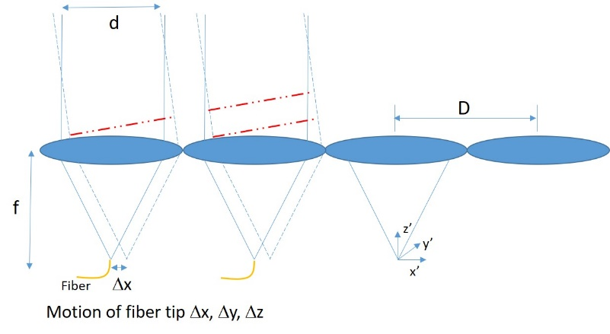

*Fig. 4. Details of array with movable fiber tip. The delivery fiber can be moved in three dimensions away from the focal point of the collimating lens.*

We start by assuming that the lens system is paraxial, and that second-order optics is sufficient to model the system. This is not a requirement, and we only make this assumption to simplify the analysis. Under this approximation, the transmittance of the collimating lens $t\left(x',y'\right)$ is given by:

$t\left(x',y'\right)=exp⁡\left[-i π \frac{({x^{'}}^{2}+{y^{'}}^{2})}{λf}\right]$, (7)

where *f* is the focal length of the collimating lens. The (*x*’,*y*’) coordinate system is centered on each sub-aperture, as indicated in fig. 4. Placing a point source (from the fiber tip) at the front focal point of this lens will result in a collimated beam exiting the sub-aperture.

If the point source is displaced from this front focal point by the amounts x, y, and z, the resulting wavefront incident on the collimating lens $u\left(x',y'\right)$ is given by:

$u\left(x',y'\right)=exp⁡\left[i π \frac{{\left(x'+Δx\right)}^{2}+{{(y}^{'}+Δy)}^{2}}{λ(f+ Δz)}\right]$. (8)

The wavefront exiting the collimating lens $u'\left(x',y'\right)$ is the product of the incident wavefront from eq. (8) and the lens transmittance from eq. (7):

$u^{'}\left(x^{'},y^{'}\right)=u\left(x^{'},y^{'}\right)∙t\left(x^{'},y^{'}\right)=\exp\left(iϕ_{1}\left(x^{'},y^{'}\right)\right)∙\exp\left(iϕ_{2}\left(x^{'},y^{'}\right)\right)∙exp⁡(iϕ_{3}(x^{'},y^{'}))$, (9)

where: $ϕ_{1}\left(x^{'},y'\right)= \frac{π(x_{0}^{2}+ y_{0}^{2})}{λ\left(f+Δz\right)}$ (Piston) (10)

$ϕ_{2}\left(x^{'},y'\right)= \frac{2π(x^{'}Δx+y^{'}Δy)}{λ\left(f+Δz\right)}$ (Tilt) (11)

$ϕ_{3}\left(x^{'},y'\right)= \frac{π ({x^{'}}^{2}+{y^{'}}^{2})Δz}{λf\left(f+Δz\right)}$ (Spherical) (12)

Performing the substitution $x^{'}=x-x_{0}$ and $y^{'}=y-y_{0}$, it is clear that an appropriate choice of $Δz$ in eq. (12) can reproduce the spherical component of the required wavefront in eq. (6). In particular,

$Δz≅ \frac{f^{2}}{z_{0}}$. (13)

Similarly, $Δx$ and $Δy$ in eq. (11) can be adjusted to reproduce the tilt component in eq. (6), namely

$Δx≅ \frac{f x_{0}}{z_{0}} , Δy≅ \frac{f y_{0}}{z_{0}}$. (14)

The piston component in eq. (10) can then be adjusted such that the sum of the phase in eq. (10) and the required piston phase in eq. (6) is reproduced modulo 2 radians by the electrooptic phase delay shown in fig. 1, where the maximum phase excursion required is 2.

There are several current methods of performing the highly accurate motion of the fiber tip required by the above system. The most common example is the optical tracking system used in a CD and DVD player. In this system, a lens is moved transversely and longitudinally by a micro-actuator to compensate for variations in track location and disk height. The current state-of-the-art of MEMS (micro-electro-mechanical systems) technology makes mass fabrication of these mechanical translation systems practical, with the corresponding economy of scale making the actuator package highly cost effective.

**Beam Steering**

It should be clear from the previous section that linear phase tilts can be applied to the phased array, resulting in beam steering. From eq. (14), it is clear that a fiber tip motion of *x* produces a beam tilt of *x*/*f* radians. The amount of beam steering required in our application is not great. The only requirement is that the beam be able to track the sky for approximately 200 seconds while removing the rotation of the earth. In this section, we analyze the diffraction properties of the phased array based on the configuration shown in fig. 1.

We apply a diffraction analysis to an array of sub-apertures shown in fig. 4. The one-dimensional wavefront exiting the N sub-apertures $u\left(x\right)$ is given by multiplying eq. (11) (with z = 0) by a finite aperture and convolving this product with a finite set of delta functions. An additional linear phase delay $\exp\left(i2παx\right)$ is applied across the entire array by the individual electronic phase modulators shown in fig. 1 to ensure proper phasing of adjacent sub-apertures:

$u\left(x\right)=\exp\left(i2π\frac{∆x∙x}{λf}\right)∙rect\left(\frac{x}{d}\right)*\left\{\frac{1}{D}comb\left(\frac{x}{D}\right)∙\exp\left(i2παx\right)∙rect\left(\frac{x}{ND}\right)\right\}$. (15)

In the above expression, we have used the common linear systems functions defined as follows:

$rect\left(x\right)= \left\{\begin{matrix}1, \left|x\right| ≤1/2 \\ 0, \left|x\right|>1/2\end{matrix}\right.$,

$comb\left(x\right)= \sum_{n=-∞}^{∞}{δ\left(x-n\right),}$

$δ(x)$ is a conventional delta function, and $*$ indicates a convolution operation.

The angular plane wave spectrum (indicating the distribution of power with respect to propagation angle $θ$) is given by calculating the Fourier transform of eq. (15):

$J\left\{u(x)\right\}= \left\{NdD sinc\left[\frac{d}{λ}\left(\sin{θ}- \frac{Δx}{f}\right)\right] \right\} ∙ \left\{comb\left[D\left(\frac{\sin{θ}}{λ}-α\right)\right] *sinc\left(ND\frac{\sin{θ}}{λ}\right)\right\},$ (16)

where $J$ denotes the Fourier transform operation and $sinc\left(x\right)= \frac{\sin\left(πx\right)}{πx}.$

The angular plane wave spectrum described by eq. (16) is plotted in fig. 5 in two curves, where the first half of the product is shown as the series of narrow sinc functions and the second half as a wide sinc function. This equation offers an accurate accounting of the light distribution, where the square of eq. (16) can be interpreted as the optical power at a particular output angle $θ$.

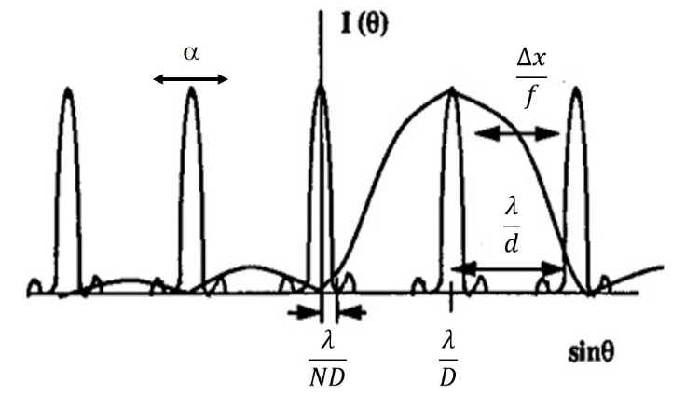

*Fig. 5. Angular plane wave spectrum of light from array from the viewpoint of the target, showing the effects of fiber tip motion* *x and array phasing* *.*

Referring to eq. (16), we observe the effect of shifting the fiber delivery tip by an amount x without any phase compensation ($α=0$). Clearly, the wide sinc function shifts in angle by an amount proportional to *x*/*f* whereas the narrow sinc functions representing the grating lobes of the array do not move. Hence the power is transferred from one grating lobe to the next. When the large sinc function is centered over a particular grating lobe (and $D=d$), the power is completely transferred to a specific grating lobe and exits the array at a single angle. However, for other shift values or when $D≠d,$ the power is distributed across several grating lobes with no single grating lobe containing all the power.

We now consider the effect of the linear phase shift applied across all the sub-apertures by the electronic phase modulators. The action of the phase function $\exp\left(i2παx\right)$ is to shift the array of grating lobes with respect to the main sinc function, and proper selection of $α$ ensures that a grating lobe is always centered under the wide sinc function in fig. 5. Hence any angle can be addressed with 100 % efficiency. The combination of a mechanical translation of the fiber tips in conjunction with electronic phasing results in continuous beam steering.

It can be seen from eq. (16) that the angular resolution of the array (given by the width of the narrow sinc function in the second-half of the equation) is simply given by

$\sin\left(θ_{min}\right)= \frac{λ}{ND}$, (17)

in accordance with an aperture size that is of diameter *ND*, where *N* is the number of sub-apertures across the center of the array. It is also apparent that the scan angle is proportional to the fiber shift *x* according to

$\sin\left(θ\right)= \frac{Δx}{f}$. (18)

We note that eq. (18) and eq. (11) are in good agreement.

We observe that the effect of the fiber motion is to achieve the proper phase distribution across each individual sub-aperture. If an error is made, the only effect is to shift the wide sinc function slightly, reducing the power in the desired grating lobe. However, the width of the grating lobe is not compromised, meaning that the resolution of the array is still diffraction-limited. This means that the required accuracy of the fiber positioners in the transverse direction is given by:

$Δx≪ \frac{λf}{D}$. (19)

The accuracy requirements of each fiber positioner is thus relatively easy to satisfy. The critical phasing to achieve diffraction-limited performance is maintained by the electronic phase shifters, which must maintain the proper piston phase across the entire array to within a phase accuracy of /2.

One way to view the above system is as a blazed diffraction grating. The diffraction grating possesses a multiplicity of grating lobes, where the power distribution across the grating lobes is a function of the shape of each grating line. If the grating lines are “blazed”, the power can be concentrated into a single grating lobe. Different blazes can concentrate the power into specific orders, giving rise to first-order blazes, second-order blazes, etc. The fiber tip motion effectively allows one to change the “blaze” of the diffraction grating (i.e. the array) at will and hence power can be diverted to any specific grating lobe. The addition of an electronic phasing ability across the entire array is equivalent to introducing a slight tip to the incoming light in a grating, and allows one to address points in between the conventional grating lobes of the diffraction grating.

**Coherence requirements and laser bandwidth**

To achieve diffraction-limited performance from the array in fig. 1, the coherence across the array must be uniformly high. Thus, the mutual coherence from the center of the array to the edge must be high. This implies that the path lengths of each aperture must be equalized to within the coherence time of the light from the master oscillator. This can be easily achieved when the array is used to produce a flat-phase wavefront by using additional lengths of fiber to equalize the path lengths from the master oscillator to each of the sub-apertures. This path-length balancing is called establishing a “true time delay” across the elements. True time systems behave like their refractive and reflective counterparts, and can, in principle, collimate a white light source with high radiance. The bandwidth requirements of the master oscillator need only satisfy the practical variations that can be achieved by path length compensation.

When the array is used to produce a focused beam, the virtual diffractive lens produced by the phase discontinuities of the array imposes an additional constraint on the laser bandwidth. When the focal length of this virtual lens is infinity, the array produces a true time delay plane wave. However, at maximum focal power, the phase delay between the center of the lens and the edge is given by the first term in eq. (5), or

$ϕ_{max}= \frac{π {\left(\frac{ND}{2}\right)}^{2}}{λz_{0}}$ (20)

The coherence length of the laser light $l_{c}$ must therefore satisfy

$l_{c} ≫ \frac{{\left(ND\right)}^{2}}{8 z_{0}}$, (21)

where we recall that *N* is the number of sub-apertures across the array, *D* is the distance between sub-apertures, and $z_{0}$ is the focal length of the virtual lens imposed onto the array (i.e. the distance to the target).

A second consideration on coherence comes from beam steering. Although the coherence requirements required by the overall fixed beam tilt can be removed by establishing true time delay with additional fixed lengths of fiber, the beam steering must operate in real time and thus requires the coherence length of the laser to be longer than the path length difference across the array when the beam is steered by its steepest angle. The path length difference across a 2700 meter diameter array steered by 19.1 mrad. is 51.8 meters, requiring a coherence length in excess of this value. Using the relationship between bandwidth $∆f$ and coherence length $Δl$ of

$$∆f = \frac{c}{Δl}$$

where *c* is the speed of light, this corresponds to a laser bandwidth of approximately 5.8 MHz.

There is an additional constraint on the coherence length and hence the bandwidth of the laser. Although eq. (21) ensures that light from the edge of the lens will interfere with light from its center, it does not ensure that the resulting focal spot will be diffraction-limited when illuminated by a different wavelength. The actual shape of the focal spot at a shifted wavelength is not straightforward to calculate, as the waveform is rather complex. However, we can calculate an upper bound by assuming the array represents a simple diffractive lens element. If one designs a diffractive lens to operate at 1 but then illuminates this lens with a laser of wavelength 2 , it is easy to show that the wavefront error from using the incorrect wavelength will be smaller than the Rayleigh limit if the fractional bandwidth satisfies

$\frac{∆λ}{\overline{λ}}< \frac{2\overline{λ}f}{{R_{0}}^{2}}$, (22)

where $∆λ= λ_{2}- λ_{1}$, $\overline{λ}= \frac{λ_{2}+ λ_{1}}{2}$, and $R_{0}$ is the radius of the lens. Evaluating this for the lenses anticipated for Starshot shows that this condition is very mild and will be easily satisfied when eq. (21) is satisfied.

**Compensation for thermal drift in fibers and free-space optics**

Returning to figure 1(a), we see that the same micropositioner element that is used to steer and focus the beam can be used to compensate for some of the changes in the free-space optics. We envision that this position alignment will be very critical to the wavefront shape and will need to be compensated by an interferometric feedback loop. Control in the transverse direction can compensate for linear phase shift errors detected in the collimated beam from each sub-aperture. Correspondingly, the quadratic phase error that results from expansion in the stage that separates the fiber from the lens can be compensated by motion of the fiber tip in the longitudinal (or optical axis) position. Each of these controls can be guided by interferometric measurements of the wavefront.

The piston errors of the fiber come from expansion of the fiber due to thermal effects from the amplifier and changes in ambient temperature. With a proper feedback signal from an interferometric measurement system, this can be compensated by the electrooptic phase shifter shown in fig. 1. Typical phase shifts when the fiber is first turned on can be thousands of waves, even for a short fiber, and it may be impractical to assume that a phase modulator can track and cancel this large of a phase excursion. However, we recall that the piston term only needs to be corrected to modulo 2 radians in phase. The additional phase discrepancy may require a system with narrow bandwidth to ensure coherence, but it can, in principle, be corrected by a simple modulator with a zero-to-2 phase modulator. This phase condition is the most critical to achieving diffraction-limited performance, as the piston error must be kept uniformly low across the entire array.

**Compensation for atmospheric turbulence**

We now consider the practical effects of propagating laser light through the atmosphere. A coarse estimate of the effect of the atmosphere on the Strehl ratio is given by the Fried parameter $r_{0}$, which is the diameter over which the atmosphere can be considered approximately uniform in phase. The phase error $σ_{ϕ}^{2}$  observed over an aperture of size *d* is then given by

rad2  (23)

where K = 1.26 when the piston error only is corrected and K = 0.18 when both piston and tip/tilt are corrected. We note that our system is, in principle, capable of canceling aberrations out to the second order (i.e. quadratic). However, measuring this aberration is more difficult and we choose to only implement the piston and tip/tilt correction.

To calculate the maximum aperture that can be used, we need to know the Fried parameter and the wavelength. Good seeing results in Fried parameters on the order of 10 cm at a wavelength of 500 nm. The Fried parameter is known to scale with wavelength according to $λ^{6/5}$. Consequently, the Fried parameter at 1.1 micrometer radiation corresponding to the same good seeing is expected to be on the order of 25 cm. This leads to the choice of 30 cm sub-aperture diameters for our straw man system. With proper metrology, the control systems described in this report should be able to compensate for atmospheric turbulence across 30 cm apertures.

The effect of atmospheric turbulence on the Strehl ratio can be calculated by combining eq. (23) with eq. (2), resulting in

$S=1- K {\left(\frac{d}{r_{0}}\right)}^{5/3},$ (24)

where we have assumed that the phase error is small. For the case where $d=30 cm$, $r_{0}=25 cm$, and K = 0.18 (i.e. piston and tip/tilt correction), the Strehl ratio is given by *S* = 0.76.

**Fault tolerance considerations**

The proposed system is highly modular, and hence is inherently fault tolerant. Failure of individual modules will not prevent the entire system from functioning. However, it should be noted that a coherent array is reduced by the square of the number of array elements lost. This is because the total on-axis power is reduced by two factors: i) the overall power of the array is reduced by the ratio of the number of functioning modules to the initial number in the array; ii) the fill factor of the array is reduced by this same number. Eq. (1) indicates that the Strehl ratio is proportional to the fill factor, reducing the amount of on-axis power by this same amount. Hence, the total amount of on-axis power is reduced by

$P_{on-axis}=P_{0}∙ \frac{M_{active}}{M_{initial}}∙\left(fill factor reduction\right)= P_{0}∙ {\left(\frac{M_{active}}{M_{initial}}\right)}^{2}$ (25)

where $P_{on-axis}$ is the on-axis power applied to the target, $P_{0}$ is the on-axis power from the fully functioning array, $M_{active}$ is the number of modules that are functioning in the array, and $M_{initial}$ is the planned number of modules in a fully functioning array.

**Performance calculations**

In this section, we assume several parameters and calculate the performance of the system.

Assumptions:

* Geographic location of array: Atacama Desert, Chile
* Height of Alpha Centauri at zenith: 51 degrees
* Laser wavelength: 1.1 m
* Gaussian beam illumination with hexagonally close packed circular apertures
* Fried parameter: 10 cm at 500 nm wavelength
* Focal length of collimating lenses: 1 meter
* Array shape and size: circular; 2700 meter diameter
* Tracking time: 200 seconds
* Maximum steering angle required for tracking: 19.1 mrad.
* Target at closest approach: $z_{0}=$ 3700 Km (geostationary orbit)

Estimated operating parameters:

* Number of sub-apertures across diameter (N) = 9000
* Diameter of beam sub-aperture: 30 cm
* Total number of hexagonally close-packed sub-apertures (M) = $\frac{{Area}_{array}}{ {Area}_{sub-aperture}}×0.907=$ 73,467,000
* Atmospheric turbulence Strehl ratio: 0.76
* Maximum transverse fiber movement required for tracking: 19.1 mm
* Maximum transverse fiber movement required for focus at geostationary orbit: 36.5 m
* Maximum longitudinal fiber movement required for focus: at geostationary orbit: 30 nm (i.e. not necessary to perform this movement for target at this distance)
* Transverse fiber movement tolerance: 3.3 m
* Estimated Strehl ratio due to Gaussian illuminated sub-apertures in a hexagonally close-packed array, atmospheric turbulence with Fried parameter of 10 cm ( = 500 nm), and phase error of feedback system (P-V = /2 radians): (0.74) (0.76) (0.81) = 0.46
* Total power per aperture required to concentrate 100 GWatts on target: 3.0 KWatts
* Required laser coherence length to compensate for beam focusing: greater than 25 cm
* Required coherence length required by beam steering: greater than 51.8 meters
* Required laser bandwidth (based on coherence length requirement for beam steering): 5.8 MHz

**Appendix**

A computer model was developed to calculate the Strehl ratio of three apertures: i) a single circular aperture, ii) an infinite array of rectangularly close-packed circular apertures, and iii) an infinite array of hexagonally close-packed apertures. These apertures were illuminated in two ways: i) uniform illumination, and ii) Gaussian illumination.

The computer model uses the Fourier transform to calculate the far-field intensity of the illuminated apertures. The singular circular aperture is zero-padded to reduce the amount of aliasing in the simulation. The aperture arrays are modeled by filling the FFT field with a unit cell of the array. Thus, the rectangularly close-packed array consists of a single circular aperture that extends across the entire FFT data field. The hexagonally close-packed array uses an asymmetric FFT that corresponds to the unit cell shown in fig. A1.

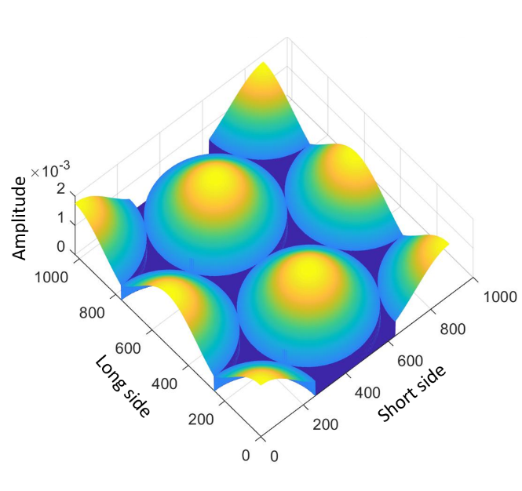

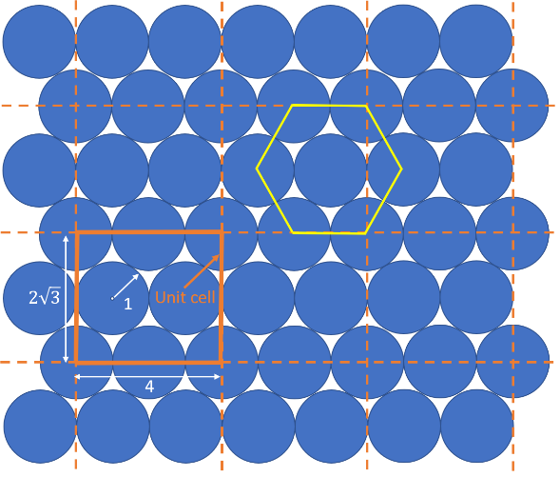

1. (b)

*Fig. A1. Model of hexagonally close-packed array of circles. a) Array showing hexagonal spacing of circular centers and one unit cell. b) FFT data field of rectangularly shaped unit cell illuminated by Gaussian beams.*

Each aperture or unit cell of apertures is illuminated with a unity power Gaussian. The squared magnitude of the dc component of the FFT then results in the Strehl ratio.

When the three aperture types are uniformly filled, the Strehl ratio can be easily computed using eq. (1), corresponding to the fill factor of the aperture. Thus, for a single circular aperture, the fill factor (with respect to a circular aperture) and the Strehl ratio is unity. This corresponds to the ideal filling of any circular lens. When the circular apertures are placed in an array corresponding to rectangular close-packing, the fill factor and Strehl are simply given by the amount of area covered by a circle that is inscribed in a square, or $π/4 = 0.785.$ Similarly, the Strehl ratio of hexagonal close-packing can be assessed by calculating the fill factor of the unit cell shown in fig. A1(a). This figure consists of two complete circles of unit radius, two half-circles of unit radius, and four quarter-circles of unit radius. Thus, the total area covered by circular apertures is given by $4πr^{2}= 4π$ for unity radius circles. The total cell area is given by $8\sqrt{3}$. Thus the fill factor and the Strehl of uniformly illuminated hexagonally close-packed circular apertures is $4π/8\sqrt{3 }$ = 0.907. The computer model agrees with these geometrically calculated values, serving as a good verification of the code.

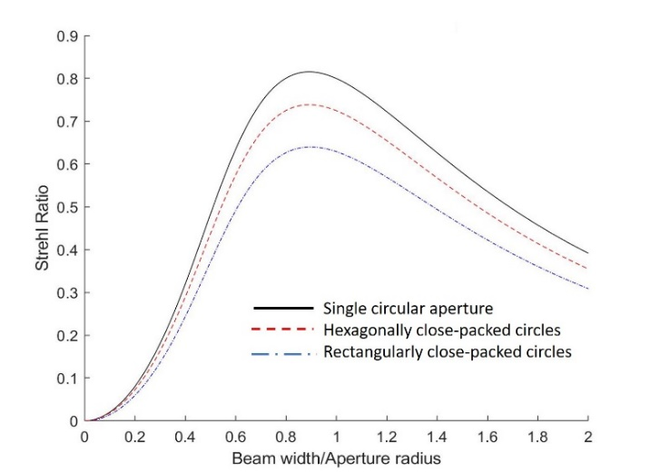The Strehl ratio of clipped Gaussian illumination cannot be calculated geometrically, and we have relied on the computer model for its evaluation. The Strehl ratio is obviously a function of the size of the Gaussian, where too small a beam results in a low fill factor (and hence low Strehl), whereas too large a beam is clipped excessively by the circular aperture, again resulting in a lower Strehl. We have calculated the Strehl ratio of the aperture as a function of beam size, where the beam width corresponds to the $\frac{1}{e^{2}}$ intensity point. The results are shown in fig. A2. Figure A2(a) shows the amount of power that is passed by a single circular aperture as a function of beam size (normalized to the radius of the aperture). Fig. A2(b) shows the calculated Strehl ratios for the three aperture types as a function of Gaussian beam size.

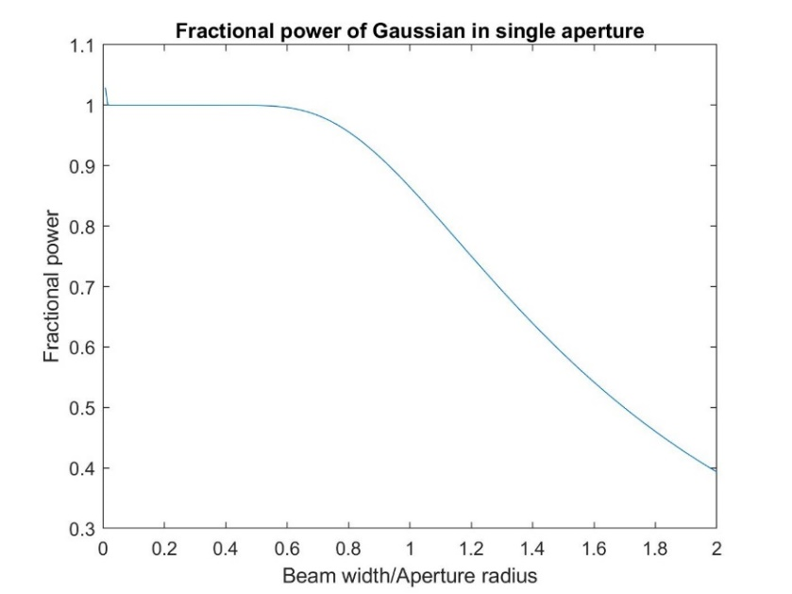

1. (b)

*Fig. A2 Results from Gaussian illumination of apertures. a) Fractional power that is passed by a single circular aperture illuminated by a Gaussian beam as a function of beam width. B) Strehl ratios of three aperture types as a function of Gaussian beam width.*

From this simulation, we have the following results for the optimum beam radius and the maximum Strehl ratios for the three aperture types. These are presented in the table below:

|  |  |  |
| --- | --- | --- |
| Aperture type | Optimum beam radius | Maximum Strehl ratio |
|  |  |  |
| Single circle | 0.89 | 0.815 |
| Hexagonally close-packed circles | 0.89 | 0.738 |
| Rectangularly close-packed circles | 0.89 | 0.639 |